PENNSYLVANIA PUBLIC UTILITY COMMISSION

Public Meeting held January 17, 2018
Docket Number: M-2018-3006643

BUREAU OF TECHNICAL UTILITY SERVICES

REPORT ON THE QUARTERLY EARNINGS

OF JURISDICTIONAL UTILITIES

FOR THE YEAR ENDED

September 30, 2018

Gladys M. Brown, Chairman
David W. Sweet, Vice Chairman
Norman J. Kennard, Commissioner
Andrew G. Place, Commissioner Statement, Dissenting
John F. Coleman, Jr., Commissioner

TABLE OF CONTENTS
Page No.

Introduction..................................................................................................... 4
* UGI Utilities, Inc. – Electric Division, Duquesne Light Company, PECO Energy - Electric, Columbia Gas, York Water, SUEZ water, and Aqua Pennsylvania have pending rate filings at Docket Nos. R-2017-2640058, R-2018-3000124, R-2018-3000164, R-2018-2647577, R-2018-3000019, R-2018-3000834, and R-2018-3003068 respectively, and filed a letter with the Secretary in place of a report in accordance with 52 Pa. Code § 71.4.

Attachment A – Summary of Equity Returns……………………………… 5

Attachment B – Summary of Returns 12
This chart depicts the overall and equity returns (actual and adjusted) for the filing utilities for the current quarter. The last authorized equity return and the year authorized is also shown.

Attachment C – Allowed Rates of Return on Common Equity 14
This is a historical chart that shows the most recent fully litigated rate cases for select companies in electric, gas, and water. A docket number followed by their final return on equity and year is also given.

Attachment D – Distribution System Improvement Charge Return on Equity 15
Compares utility adjusted return on equity to Commission authorized return on equity for utilities with a Distribution System Improvement Charge.

Attachment E – Explanation of Return on Equity Methods 16
Criteria for determining the industry barometer groups used in ROE calculations. Also, provides details of the Discounted Cash Flow equation and Capital Asset Pricing Model equation.

Attachment F – Market Based Returns on Equity – Electric 18
The market indicated common equity cost rate range consists of data used from the electric barometer groups and is based on a series of calculations to average the DCF methods. Also, indicates Distribution System Improvement Charge Return.

Attachment F – Historic DCF and CAPM – Electric 19
Historic barometer group DCF and CAPM average ROEs, including a linear trend line graph.

Attachment F – Electric Barometer Group Calculation of a Current and 52 Week Average Dividend Yield 20
Electric barometer companies are used to calculate a current DCF in the first chart. The second chart demonstrates the companies 52 week average DCF. A final average of the two calculations is also shown at the bottom.

Attachment F – Development of a Representative Dividend Growth Rate…………………………………………………... 21
Multiple sources of the gas barometer companies projected 5 year Earnings Per Share are used to calculate the Group Average Dividend Growth Estimate.

Attachment G – Market Based Returns on Equity – Gas 22
The market indicated common equity cost rate range consists of data used from the gas barometer groups and is based on a series of calculations to average the DCF methods. Also, indicates Distribution System Improvement Charge Return.

Attachment G – Historic DCF and CAPM – Gas 23
Historic barometer group DCF and CAPM average ROEs, including a linear trend line graph.

Attachment G – Gas Barometer Group Calculation of a Current and 52 Week Average Dividend Yield 24
Gas barometer companies are used to calculate a current DCF in the first chart. The second chart demonstrates the companies 52 week average DCF. A final average of the two calculations is also shown at the bottom.

Attachment G – Development of a Representative Dividend Growth Rate…………………………………………………... 25
Multiple sources of the gas barometer companies projected 5 year Earnings Per Share are used to calculate the Group Average Dividend Growth Estimate.

Attachment H – Market Based Returns on Equity – Water 26
The market indicated common equity cost rate range consists of data used from the water barometer groups and is based on a series of calculations to average the DCF methods. Also, indicates Distribution System Improvement Charge Return.

Attachment H – Historic DCF and CAPM – Water 27
Historic barometer group DCF and CAPM average ROEs, including a linear trend line graph.

Attachment H – Water Barometer Group Calculation of a Current and 52 Week Average Dividend Yield 28
Water barometer companies are used to calculate a current DCF in the first chart. The second chart demonstrates the companies 52 week average DCF. A final average of the two calculations is also shown at the bottom.

Attachment H – Development of a Representative Dividend Growth Rate…………………………………………………... 29
Multiple sources of the water barometer companies projected 5 year Earnings Per Share are used to calculate the Group Average Dividend Growth Estimate.

Introduction:

On September 20, 1991, the Commission initiated a rulemaking at L-00910061 pertaining to earnings disclosures by the public utilities subject to its jurisdiction. At that docket, the Commission stated that the submission of accurate, reliable and complete earnings disclosure reports, at regular intervals, is essential to the fulfillment of the broad regulatory oversight responsibilities entrusted to the Commission by the Legislature in the Public Utility Code. The earnings disclosure regulations promulgated by the Commission were adopted October 1, 1992, and published January 23, 1993, at 23 Pa.B. 463. Based upon those regulations, codified at 52 Pa. Code, Chapter 71, a reporting format was developed and distributed to the jurisdictional fixed utilities of Pennsylvania.

All fixed utilities having jurisdictional revenues of $1,000,000 or more, for a calendar year, are required to file the report by March 31 of each year. Such reports are to be based upon the results of operations for the 12-month period ending December 31 of the prior year. Utilities having more than $10,000,000 in jurisdictional revenues are also required to file reports for the 12 months ending on March 31, June 30, and September 30 of each year. On November 30, 2004, however, the Pennsylvania General Assembly signed into law Act 183 concerning alternative telecommunications regulation and broadband deployment. As a result of Act 183, the reporting requirements for the PUC jurisdictional telecommunications companies of Pennsylvania have been streamlined at section 3015(e) of the Public Utility Code. A quarterly earnings report is not listed among those reports now required of PUC jurisdictional telecommunications utilities in Pennsylvania and, therefore, this report does not address telephone company earnings.

The reports have been filed for the period ended June 30, 2018. The Finance Staff of the Bureau of Technical Utility Services has reviewed the reports and has prepared this summary report for public release. This report sets forth the achieved return on equity for each company, the last allowed return for that utility, a market return as determined through the analysis of the barometer group data and the most recent returns allowed, per industry, by the Pennsylvania Public Utility Commission and by other regulatory bodies. Where a utility has not filed a report, the reasons for not filing are indicated.

Questions pertaining to the preparation and contents of this Report should be directed to Ms. Erin Laudenslager, Manager - Finance, Bureau of Technical Utility Services, at (717) 705-4364.

The equity return summaries that follow in Attachment A are, for each quarter;

ACTUAL
- Based on actual results of operations

and

ADJUSTED
2. Based on company proposed pro forma and ratemaking adjustments

ELECTRIC UTILITIES
EQUITY RETURNS BY QUARTER
QTR  END |  | PECO |  | PPL |  | Duq |  | W Penn |  | PaPwr |  |  |  | UGI |  | Penelec |  | MetEd
 |  | ACT | ADJ | ACT | ADJ | ACT | ADJ | ACT | ADJ |  | ACT | ADJ |  | ACT | ADJ | ACT | ADJ | ACT | ADJ
2012 | 4 | 11.55 | 11.56 | 6.02 | 4.88 | 10.27 | 9.24 | 9.54 | 9.54 |  | 8.41 | 8.27 |  | 14.60 | 8.98 | 5.41 | 7.74 | 5.39 | 6.81
2013 | 1 | 11.92 | 11.27 | 7.56 | 6.24 | 10.12 | 9.74 | 9.23 | 9.23 |  | 8.89 | 8.74 |  | 12.77 | 9.84 | 5.30 | 7.67 | 5.01 | 6.47
 | 2 | 11.40 | 10.74 | 7.80 | 7.37 |  |  | 12.34 | 12.34 |  | 8.85 | 8.70 |  | 11.53 | 10.49 | 5.86 | 8.21 | 5.36 | 6.79
 | 3 | 11.09 | 10.96 | 8.67 | 8.38 |  |  | 9.13 | 9.13 |  | 8.49 | 8.34 |  | 10.74 | 10.65 | -0.77 | 2.07 | -12.43 | -10.43
 | 4 | 11.97 | 10.52 | 10.01 | 9.79 |  |  | 13.73 | 13.73 |  | 14.49 | 14.30 |  | 14.25 | 11.99 | 4.85 | 2.99 | -6.06 | -7.87
2014 | 1 | 9.97 | 10.34 | 10.02 | 10.04 |  |  | 11.58 | 9.45 |  | 15.28 | 15.04 |  | 13.36 | 10.25 | 5.17 | 3.34 | -6.40 | -8.13
 | 2 | 10.05 | 10.08 | 9.50 | 10.09 | 9.77 | 9.29 |  |  |  |  |  |  | 12.64 | 9.21
 | 3 | 8.93 | 9.25 | 10.07 | 9.99 | 9.97 | 9.48 |  |  |  |  |  |  | 8.76 | 9.22
 | 4 | 8.23 | 9.58 |  |  | 9.77 | 9.40 |  |  |  |  |  |  | 9.01 | 10.00
2015 | 1 |  |  |  |  | 10.08 | 9.65 |  |  |  |  |  |  | 10.88 | 10.39
 | 2 |  |  |  |  | 9.80 | 9.42 |  |  |  |  |  |  | 13.57 | 9.49
 | 3 |  |  |  |  | 10.11 | 9.73 | 6.45 | 6.45 |  | 5.77 | 5.77 |  | 15.93 | 7.57 | 2.94 | 2.94 | 3.69 | 3.69
 | 4 | 10.74 | 8.84 | 8.89 | 8.48 | 9.73 | 9.36 | 8.09 | 8.09 |  | 5.13 | 5.13 |  | 9.74 | 9.21 | 5.45 | 5.45 | 7.04 | 7.04
2016 | 1 | 10.86 | 9.74 | 7.75 | 6.94 | 9.87 | 9.89 |  |  |  |  |  |  | 10.41 | 8.69
 | 2 | 11.46 | 10.15 | 9.15 | 8.51 | 9.57 | 9.47 |  |  |  |  |  |  | 8.29 | 8.10
 | 3 | 13.42 | 11.44 | 10.15 | 9.59 | 10.12 | 9.46 |  |  |  |  |  |  | 19.18 | 6.99
 | 4 | 12.52 | 10.65 | 10.45 | 10.29 | 9.71 | 9.01 |  |  |  |  |  |  | 26.07 | 7.30
2017 | 1 | 13.01 | 11.40 | 9.76 | 8.49 | 9.53 | 8.99 |  |  |  |  |  |  | 22.86 | 6.81
 | 2 | 12.98 | 11.40 | 10.71 | 9.70 | 9.86 | 9.24 | 8.23 | 7.38 |  | 7.32 | 7.97 |  | 21.96 | 6.74 | 9.23 | 9.20 | 9.74 | 9.35
 | 3 | 12.84 | 10.52 | 10.15 | 9.30 | 9.53 | 9.23 | 7.63 | 7.24 |  | 8.32 | 9.08 |  | 16.13 | 5.22 | 9.61 | 9.50 | 11.37 | 10.97
 | 4 | 12.07 | 9.11 | 11.07 | 10.63 |  |  | 9.47 | 9.12 |  | 8.46 | 8.19 |  |  |  | 11.70 | 10.93 | 12.58 | 11.67
2018 | 1 |  |  | 12.53 | 11.36 |  |  | 10.35 | 9.08 |  | 9.03 | 8.08 |  |  |  | 11.84 | 9.93 | 12.77 | 11.38
 | 2 |  |  | 11.05 | 9.49 |  |  | 9.92 | 8.52 |  | 8.79 | 7.57 |  |  |  | 11.56 | 9.39 | 11.90 | 10.26
 | 3 |  |  | 11.19 | 9.83 |  |  | 11.41 | 6.74 |  | 10.30 | 5.80 |  |  |  | 13.97 | 8.44 | 14.46 | 9.62
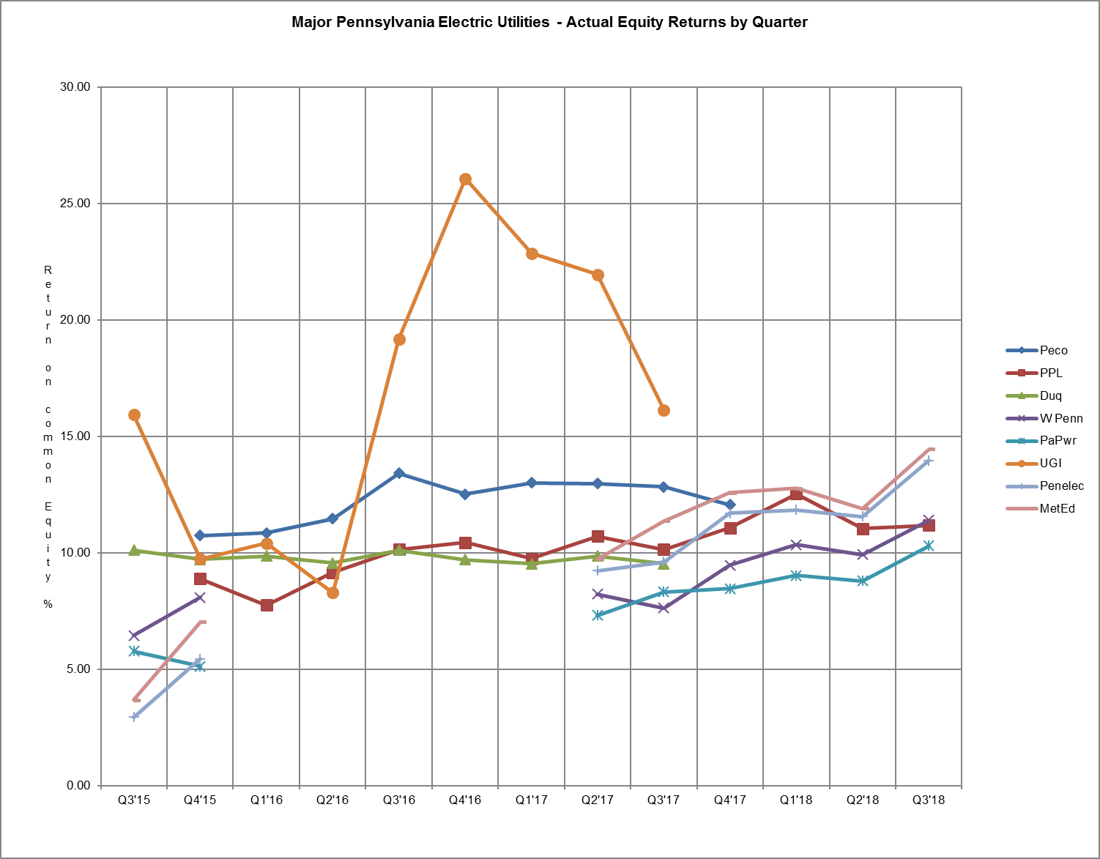
GAS UTILITIES
EQUITY RETURNS BY QUARTER

QTR |  |  | Columbia |  | Peoples Natural |  | PECO |  | UGI  South |  | Peoples-Equitable |  | NFG |  | UGI  North |  | Peoples  Gas
END |  |  | ACT | ADJ | ACT | ADJ | ACT | ADJ | ACT | ADJ | ACT | ADJ | ACT | ADJ | ACT | ADJ | ACT | ADJ
2012 | 4 |  |  |  | 11.24 | 9.57 | 12.42 | 15.10 | 13.68 | 9.44 | 7.27 | 8.05 | 15.11 | 10.17 | 13.31 | 10.63 | 5.05 | 6.94
2013 | 1 |  |  |  | 12.49 | 9.89 | 14.63 | 15.13 | 14.65 | 10.27 | 12.42 | 8.40 | 19.33 | 10.25 | 13.28 | 10.58
 | 2 |  | 10.85 | 7.15 | 16.59 | 8.35 | 14.43 | 14.40 | 13.02 | 10.21 | 10.40 | 8.92 | 20.18 | 10.25 | 10.98 | 10.27
 | 3 |  | 9.36 | 9.86 | 17.39 | 8.72 | 14.14 | 14.01 | 12.60 | 9.38 | 9.84 | 9.48 | 19.61 | 10.72 | 10.59 | 10.76
 | 4 |  | 10.60 | 10.78 | 16.33 | 10.02 | 14.35 | 13.97 | 16.08 | 9.20 | 10.52 | 9.76 | 20.51 | 10.07 | 13.41 | 10.49 | 7.21 | 12.23
2014 | 1 |  |  |  | 14.68 | 9.94 | 15.23 | 13.52 | 16.81 | 8.35 | 12.00 | 8.73 | 23.11 | 9.78 | 16.67 | 10.06 | 12.19 | 11.87
 | 2 |  |  |  | 13.05 | 9.78 | 15.32 | 13.24 | 16.71 | 8.39 | 13.54 | 8.49 | 22.97 | 12.00 | 15.30 | 10.90 | 14.06 | 12.32
 | 3 |  |  |  | 13.43 | 9.16 | 15.45 | 13.21 | 16.63 | 8.64 | 14.41 | 9.15 | 21.36 | 11.03 | 13.77 | 10.15 | 15.07 | 12.62
 | 4 |  | 9.71 | 9.97 | 11.85 | 7.89 | 13.86 | 12.59 | 15.00 | 7.93 | 14.52 | 12.46 | 20.40 | 10.79 | 15.64 | 9.82 | 16.91 | 11.83
2015 | 1 |  |  |  | 14.22 | 7.90 | 14.60 | 13.01 | 15.76 | 7.87 | 15.36 | 12.14 | 20.17 | 10.31 | 15.57 | 9.52 | 16.36 | 11.23
 | 2 |  |  |  | 14.37 | 8.88 | 13.89 | 12.32 | 14.07 | 7.62 | 14.08 | 11.26 | 18.82 | 10.39 | 13.76 | 8.90 | 16.15 | 12.90
 | 3 |  |  |  | 13.55 | 8.14 | 13.29 | 11.77 | 15.67 | 6.51 | 11.30 | 10.87 | 16.41 | 10.27 | 13.16 | 8.32 | 15.69 | 12.58
 | 4 |  | 9.75 | 9.73 | 8.80 | 9.83 | 12.50 | 12.70 |  |  | 10.60 | 10.00 | 15.01 | 10.59 | 9.17 | 7.25 | 12.71 | 12.14
2016 | 1 |  |  |  | 7.01 | 10.02 | 10.73 | 13.58 |  |  | 8.98 | 10.20 | 12.60 | 10.97 | 7.85 | 8.85 | 8.54 | 10.48
 | 2 |  |  |  | 6.24 | 9.99 | 11.55 | 13.85 |  |  | 8.29 | 10.40 | 12.31 | 11.08 | 9.41 | 8.37 | 9.20 | 10.43
 | 3 |  |  |  | 6.93 | 9.34 | 12.09 | 14.40 |  |  | 13.05 | 10.82 | 13.00 | 10.34 | 6.47 | 8.81 | 9.07 | 12.02
 | 4 |  | 8.90 | 9.26 | 10.11 | 11.03 | 11.39 | 12.37 |  |  | 16.42 | 11.07 | 14.18 | 9.58 |  |  | 12.47 | 11.87
2017 | 1 |  | 10.52 | 10.17 | 9.96 | 9.27 | 11.45 | 12.55 | 21.08 | 10.09 | 15.85 | 10.58 | 12.84 | 9.26 |  |  | 11.82 | 12.34
 | 2 |  | 9.15 | 9.81 | 9.41 | 9.71 | 10.87 | 12.17 | 19.16 | 9.44 | 15.66 | 10.30 | 13.33 | 10.53 |  |  | 11.89 | 13.47
 | 3 |  | 8.15 | 8.77 | 6.69 | 6.40 | 11.26 | 10.92 | 13.34 | 9.03 | 12.59 | 9.85 | 10.92 | 10.00 |  |  | 12.04 | 13.36
 | 4 |  | 7.76 | 8.48 | 9.66 | 7.27 | 11.48 | 9.83 | 11.06 | 8.62 | 11.28 | 9.23 | 11.58 | 10.56 |  |  | 12.65 | 11.79
2018 | 1 |  |  |  | 11.42 | 7.00 | 12.65 | 9.77 | 12.82 | 7.90 | 12.68 | 8.22 | 14.40 | 10.20 | 16.95 | 7.83 | 14.02 | 10.17
 | 2 |  |  |  | 11.03 | 6.80 | 12.66 | 9.05 | 16.75 | 6.80 | 11.81 | 9.57 | 12.06 | 9.89 | 17.68 | 8.02 | 12.78 | 10.15
 | 3 |  |  |  | 10.21 | 7.43 | 12.54 | 8.36 | 18.69 | 8.04 | 10.99 | 9.44 | 12.52 | 10.12 | 20.60 | 9.16 | 13.03 | 10.20
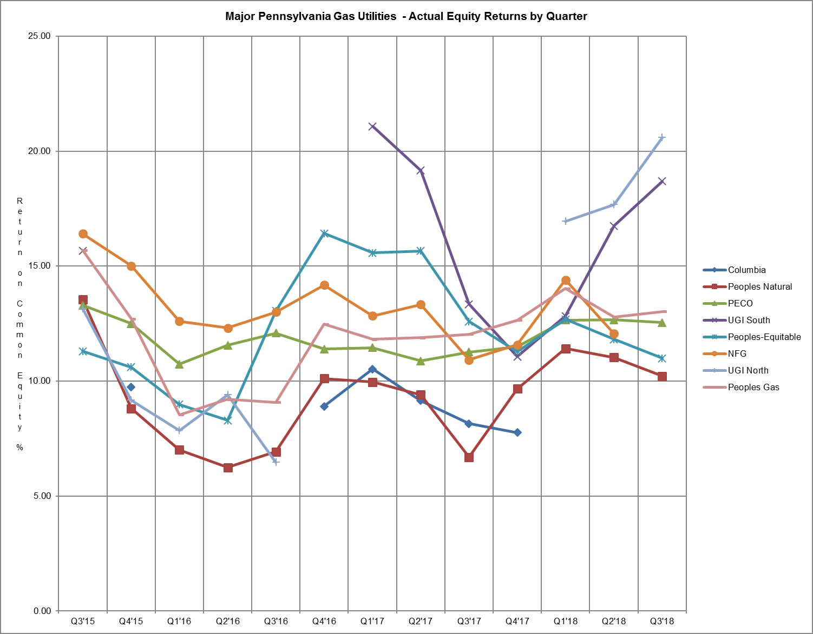

WATER UTILITIES
EQUITY RETURNS BY QUARTER
QTR |  | PAWC |  | AQUA |  | SUEZ |  | York |  | Superior
END |  | ACT | ADJ | ACT | ADJ | ACT | ADJ | ACT | ADJ | ACT | ADJ
2012 | 4 | 9.54 | 9.04 | 12.41 | 12.56 | 8.33 | 8.49 | 10.4 | 9.1
2013 | 1 |  |  | 13.24 | 11.96 | 8.53 | 8.71
 | 2 |  |  | 14.26 | 12.52 | 8.99 | 9.15 |  |  | 8.57 | 7.85
 | 3 |  |  | 15.49 | 12.21 | 8.83 | 9.01 |  |  | 7.46 | 6.85
 | 4 |  |  | 13.77 | 11.97 | 8.43 | 9.05 | 10.2 | 10.8 | 10.71 | 10.01
2014 | 1 | 10.52 | 9.98 | 13.29 | 11.56 | 8.45 | 9.02 | 10.2 | 10.2 | 13.12 | 9.97
 | 2 | 10.51 | 10.02 | 13.01 | 11.42 | 8.81 | 9.32 | 10.7 | 10.7 | 17.09 | 9.61
 | 3 | 11.11 | 10.57 | 12.82 | 11.29 | 8.57 | 9.06 | 10.9 | 10.9 | 34.68 | 9.88
 | 4 | 10.49 | 9.38 | 12.62 | 11.49 | 8.90 | 9.44 | 12.3 | 11.6 | 16.74 | 7.96
2015 | 1 | 10.33 | 9.14 | 12.46 | 11.11 | 9.11 | 9.83 | 12.7 | 12.7 | 15.92 | 8.37
 | 2 | 10.51 | 9.31 | 12.66 | 11.62 | 8.36 | 9.25 | 12.7 | 12.7 | 14.65 | 8.93
 | 3 | 10.06 | 8.81 | 12.41 | 11.95 | 8.39 | 9.37 | 13.6 | 13.6 | 12.54 | 9.37
 | 4 | 9.80 | 8.48 | 12.61 | 12.16 | 8.54 | 8.77 | 12.50 | 11.10 | 12.73 | 9.50
2016 | 1 | 10.12 | 8.68 | 12.31 | 11.71 | 9.27 | 10.19 | 12.40 | 10.90 | 11.91 | 8.17
 | 2 | 9.99 | 8.47 | 11.71 | 11.21 | 11.00 | 12.37 | 12.20 | 10.80 | 12.07 | 7.90
 | 3 | 9.82 | 8.47 | 11.55 | 10.32 | 8.23 | 9.99 | 12.20 | 11.00 | 14.99 | 7.25
 | 4 | 9.37 | 8.51 | 11.70 | 10.57 | 9.13 | 9.90 | 11.50 | 10.40 | 8.24 | 5.04
2017 | 1 |  |  | 11.34 | 10.04 | 9.22 | 9.60 | 11.61 | 9.50 | 10.29 | 9.13
 | 2 |  |  | 10.99 | 9.22 | 9.03 | 9.07 | 11.60 | 9.10 | 10.74 | 8.61
 | 3 |  |  | 10.99 | 9.23 | 8.57 | 8.57 | 11.60 | 8.70 | 8.82 | 8.25
 | 4 |  |  | 11.05 | 8.63 | 8.75 | 8.73 | 11.30 | 8.40 | 8.56 | 8.69
2018 | 1 | 9.55 | 8.97 | 10.94 | 8.41 |  |  |  |  | 5.64 | 7.39
 | 2 | 10.27 | 9.65
 | 3 | 11.03 | 9.48
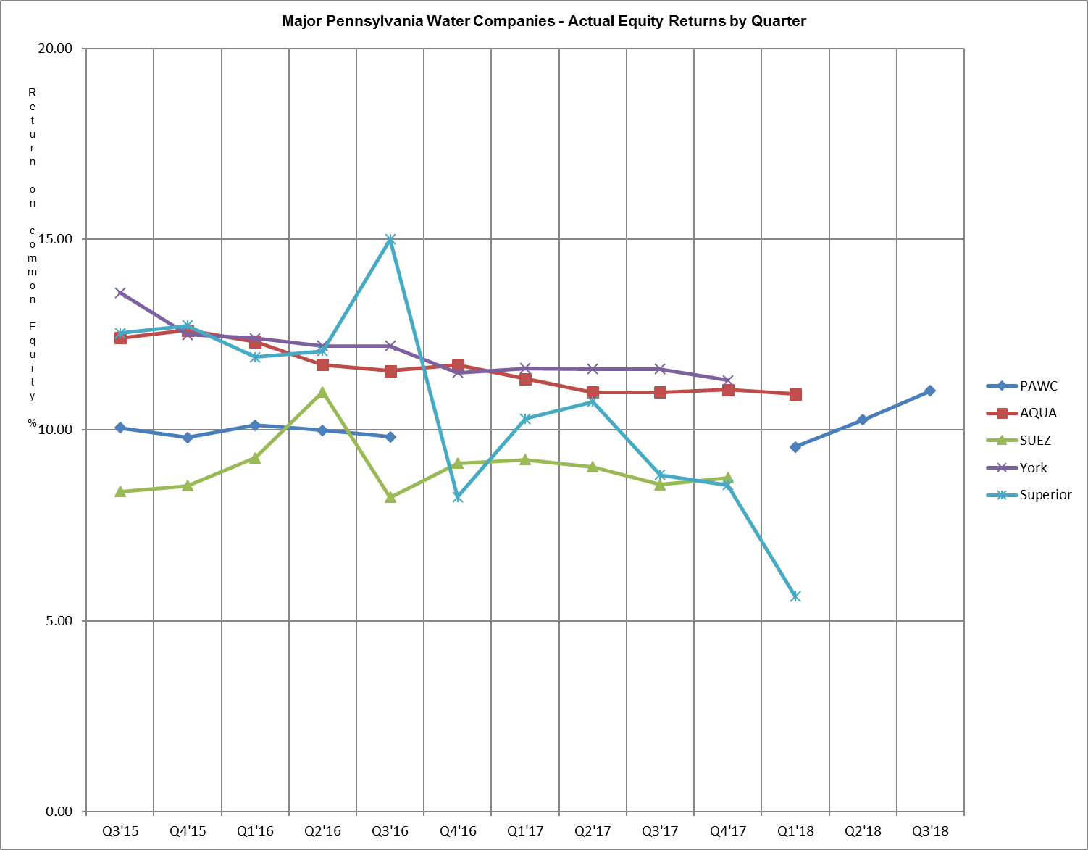

Attachment B includes:

A. Overall Returns on rate base
1. Actual
2. Company proposed pro forma and ratemaking adjustments

and

B. Equity Returns
1. Actual
2. Company proposed pro forma and ratemaking adjustments

Summary of Returns
For the Year Ended September 30, 2018
 | OVERALL RETURN |  | EQUITY RETURN |  | ROE | YEAR
COMPANY NAME | ACTUAL | ADJ | ACTUAL | ADJ | AUTH | AUTH
ELECTRIC
$10,000,000 Revenues
PECO Energy - Electric Operations* |  |  |  |  | Settled | 2015
PPL Electric Utilities Corp. | 8.18 | 7.44 | 11.19 | 9.83 | Settled | 2015
Duquesne Light Company* |  |  |  |  | Settled | 2014
West Penn Power Company | 8.05 | 5.48 | 11.41 | 6.74 | Settled | 2017
Pennsylvania Power Company | 8.38 | 5.71 | 10.30 | 5.80 | Settled | 2017
UGI Utilities, Inc. - Electric Division* |  |  |  |  | 9.85 | 2018
Pennsylvania Electric Company | 9.89 | 6.83 | 13.97 | 8.44 | Settled | 2017
Metropolitan Edison Company | 10.30 | 7.59 | 14.46 | 9.62 | Settled | 2017
GAS
$10,000,000 Revenues
Columbia Gas of PA, Inc.* |  |  |  |  | Settled | 2016
Peoples Natural Gas Company LLC | 7.48 | 5.93 | 10.21 | 7.43 | Settled | 2012
PECO Energy - Gas Operations | 8.49 | 6.15 | 12.54 | 8.36 | Settled | 2010
UGI Utilities, Inc. - South | 9.45 | 6.51 | 18.69 | 8.04 | Settled | 2016
Peoples Nat’l - Equitable Division | 7.91 | 6.97 | 10.99 | 9.44 | Settled | 2008
National Fuel Gas Distribution Co. | 8.54 | 7.21 | 12.52 | 10.12 | Settled | 2006
UGI Utilities, Inc. - North | 11.65 | 7.08 | 20.60 | 9.16 | Settled | 2017
Peoples Gas Company, LLC | 8.78 | 7.27 | 13.03 | 10.20 | Settled | 2013
UGI Utilities, Inc. - Central | 11.42 | 5.86 | 20.69 | 6.93 | Settled | 2009
WATER
$10,000,000 Revenues
PA American Water Company | 8.26 | 7.37 | 11.03 | 9.48 | Settled | 2018
Aqua Pennsylvania* |  |  |  |  | Settled | 2012
York Water Company* |  |  |  |  | Settled | 2014
SUEZ Water Pennsylvania, Inc.* |  |  |  |  | Settled | 2015

* UGI Utilities, Inc. – Electric Division, Duquesne Light Company, PECO Energy - Electric, Columbia Gas, York Water, SUEZ water, and Aqua Pennsylvania have pending rate filings at Docket Nos. R-2017-2640058, R-2018-3000124, R-2018-3000164, R-2018-2647577, R-2018-3000019, R-2018-3000834, and R-2018-3003068 respectively, and filed a letter with the Secretary in place of a report in accordance with 52 Pa. Code § 71.4.

ALLOWED RATES OF RETURN ON COMMON EQUITY
This is a historical chart that shows the most recent fully litigated rate cases for select companies in electric, gas, and water. A docket number followed by their final return on equity and year is also given.

ELECTRIC Docket Number ROE (%) Year

Recent PA PUC Allowed
PPL Electric Utilities Corp. R-2015-2469275 Settled 2015
PECO Energy Company R-2015-2468981 Settled 2015
UGI - Electric R-2017-2640058 9.85 2018
Pennsylvania Electric Company R-2016-2537352 Settled 2017
Metropolitan Edison Company R-2016-2537349 Settled 2017
Pennsylvania Power Company R-2016-2537359 Settled 2017
West Penn Power Company R-2016-2537355 Settled 2017

Current Market Indicated ROE as calculated by the 8.51-9.51
Bureau of Technical Utility Services.

GAS

Recent PA PUC Allowed
Columbia Gas of Pa. R-2016-2529660 Settled 2016
UGI Utilities, Inc. - South R‑2015‑2518438 Settled 2016
Peoples Natural Gas R-2012-2285985 Settled 2012
UGI Utilities, Inc. - North R-2016-2580030 Settled 2017
UGI Utilities, Inc. - Central R-2008-2079675 Settled 2009
PECO Energy R-2010-2161592 Settled 2010
Peoples TWP R-2013-2355886 Settled 2013

Current Market Indicated ROE as calculated by the 7.17-12.75
Bureau of Technical Utility Services.

WATER

Recent PA PUC Allowed
Aqua Pennsylvania R-2011-2267958 Settled 2012
PA American Water R-2017-2595853 Settled 2017
Columbia Water R-2017-2598203 Settled 2015
York Water R-2012-2336379 Settled 2014

Current Market Indicated ROE as calculated by the 8.57-10.76
Bureau of Technical Utility Services.

Distribution System Improvement Charge (DSIC) Eligible Utilities
Return on Equity (ROE) Summary

 |  |  | Utility Adjusted  ROE (%) |  | Commission Approved  ROE (%)
ELECTRIC
PECO Energy – Electric Operations* |  |  |  |  | 9.65
PPL Electric Utilities Corp. |  |  | 9.83 |  | 9.65
Duquesne Light Company* |  |  |  |  | 9.65
West Penn Power Company |  |  | 6.74 |  | 9.65
Pennsylvania Power Company |  |  | 5.80 |  | 9.65
Pennsylvania Electric Company |  |  | 8.44 |  | 9.65
Metropolitan Edison Company |  |  | 9.62 |  | 9.65
GAS
Columbia Gas of PA, Inc.* |  |  |  |  | 10.15
Peoples Natural Gas Company LLC |  |  | 7.43 |  | 10.15
PECO Energy – Gas Operations |  |  | 8.36 |  | 10.15
UGI Utilities, Inc. – South |  |  | 8.04 |  | 10.15
Peoples-Equitable Division |  |  | 9.44 |  | 10.15
UGI Utilities, Inc. – North |  |  | 9.16 |  | 10.15
Peoples Gas Company, LLC |  |  | 10.20 |  | 10.15
UGI Utilities, Inc. – Central |  |  | 6.93 |  | 10.15
WATER
PA American Water Company |  |  | 9.48 |  | 9.95
PA American – Wastewater |  |  | 9.48 |  | 9.95
AQUA Pennsylvania* |  |  |  |  | 9.95
AQUA Pennsylvania – Wastewater* |  |  |  |  | 9.95
York Water Company* |  |  |  |  | 9.95
SUEZ Water Pennsylvania Inc.* |  |  |  |  | 9.95
Columbia Water Company |  |  | 5.17 |  | 9.95
Newtown Artesian Water |  |  | 3.97 |  | 9.95
Superior Water* |  |  |  |  | 9.95
* UGI Utilities, Inc. – Electric Division, Duquesne Light Company, PECO Energy - Electric, Columbia Gas, York Water, SUEZ Water, and Aqua Pennsylvania, Aqua Pennsylvania-Wastewater and Superior Water have pending rate filings at Docket Nos. R-2017-2640058, R-2018-3000124, R-2018-3000164, R-2018-2647577, R-2018-3000019, R-2018-3000834, and R-2018-3003068 respectively, and filed a letter with the Secretary in place of a report in accordance with 52 Pa. Code § 71.4.

Explanation of Discounted Cash Flow (DCF) and Capital Asset Pricing Model (CAPM)

Barometer Group Criteria

The criteria used for determining the industry barometer groups used to calculate ROEs in this report are as follows:

- 50% or more of the company’s assets must be related to the jurisdictional utility industry;
- The company’s stock must be publicly traded;
- Companies involved in merger & acquisition activity will be excluded;
- Investment information for the company must be available to the Commission from more than one source; and
- Geographic Regions:
EDCs: Value Line East, Central, and West Group Electric Utility companies;
NGDCs: Value Line Investment Survey’s Natural Gas Utility industry group companies;
Water/Waste water: Value Line Investment Survey’s Water Utility industry group companies.

The barometer group companies are reviewed by staff on a quarterly basis and make any changes to these companies based upon the criteria above.

ROE Calculations

The Commission consistently uses the DCF model to determine the appropriate cost of equity for utilities. In this report, the DSIC ROE is calculated using two DCF models.

TUS uses the following formula to calculate the current dividend DCF: K = D₁/P₀ + G

TUS uses the following formula to calculate the 52-week average dividend DCF: K = D₀/P_{a} + G

Definitions:
K = Cost of equity
D₁ = Dividend expected during the year
= D₀ + ½g
D₀ = Latest indicated dividend, obtained from Yahoo! Finance
g = Expected 5-year dividend growth rate of barometer group obtained from Value Line Investment Survey.
P₀ = Current price of the stock, obtained from Yahoo! Finance
P_{a} = Average of high and low stock price over the latest 52-week period, obtained from Yahoo! Finance
G = Average of 5-year expected earnings growth rate forecasts obtained from Value Line Investment Survey, Zacks Investment Survey, Yahoo! Finance, Morningstar and/or Reuters.

The CAPM uses the yield of a risk-free interest bearing obligation plus a rate of return premium that is proportional to the systematic risk of an investment.

TUS uses the following formula to calculate CAPM: K = β(R_{m}-R_{f})

Three components are necessary to calculate the CAPM cost of equity:

β = Beta, a measure of systematic risk for each stock

R_{f} = The risk-free rate of return, 10-year U.S. Treasury yields are used for R_{f} .
Yields are taken from the previous two quarters and forecasted next four quarters.

R_{m} = Total return of the equity market as determined by the SBBI Yearbook

The Commission determines the ROE used for DSIC purposes based on the range of reasonableness from the DCF barometer group data, CAPM data, recent ROEs adjudicated by the Commission, and informed judgment.

The market indicated common equity cost rate range consists of data used from the barometer groups and is based on a series of calculations to average the DCF methods.

Historic Electric Industry Barometer Group DCF and CAPM Average ROEs

Chart of Historic Electric Industry DCF and CAPM Average ROEs

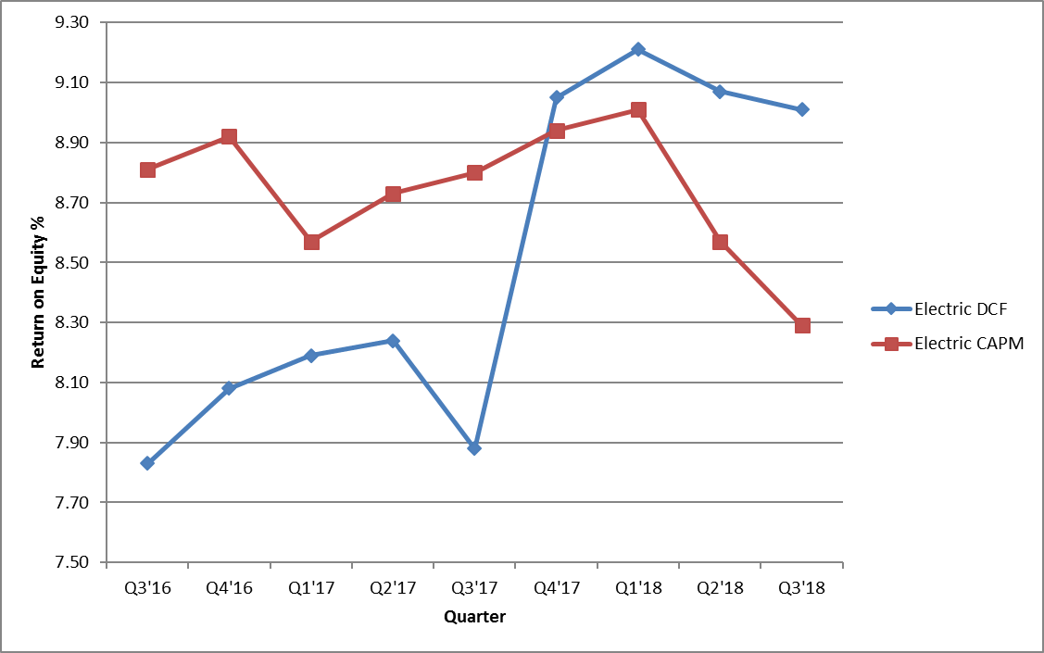

Barometer electric companies are used to calculate a current DCF in the first chart. The second chart demonstrates the companies 52 week average DCF. A final average of the two calculations is also shown at the bottom.

Multiple sources of the Barometer companies projected 5 year Earnings Per Share are used to calculate the Group Average Dividend Growth Estimate.

The market indicated common equity cost rate range consists of data used from the barometer groups and is based on a series of calculations to average the DCF methods.

Historic Gas Industry DCF and CAPM Average ROEs

Graph of Historic Gas Industry DCF and CAPM Average ROEs

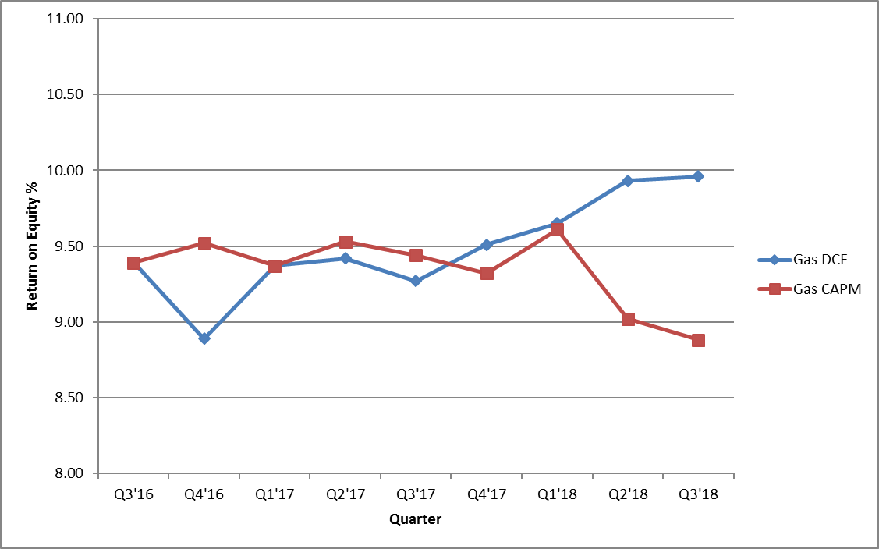

Barometer gas companies are used to calculate a current DCF in the first chart. The second chart demonstrates the companies 52 week average DCF. A final average of the two calculations is also shown at the bottom.

Multiple sources of the Barometer companies projected 5 year Earnings Per Share are used to calculate the Group Average Dividend Growth Estimate.

The market indicated common equity cost rate range consists of data used from the barometer groups and is based on a series of calculations to average the DCF methods.

Historic Water Industry DCF and CAPM Average ROEs

Chart of Historic Water Industry DCF and CAPM Average ROEs

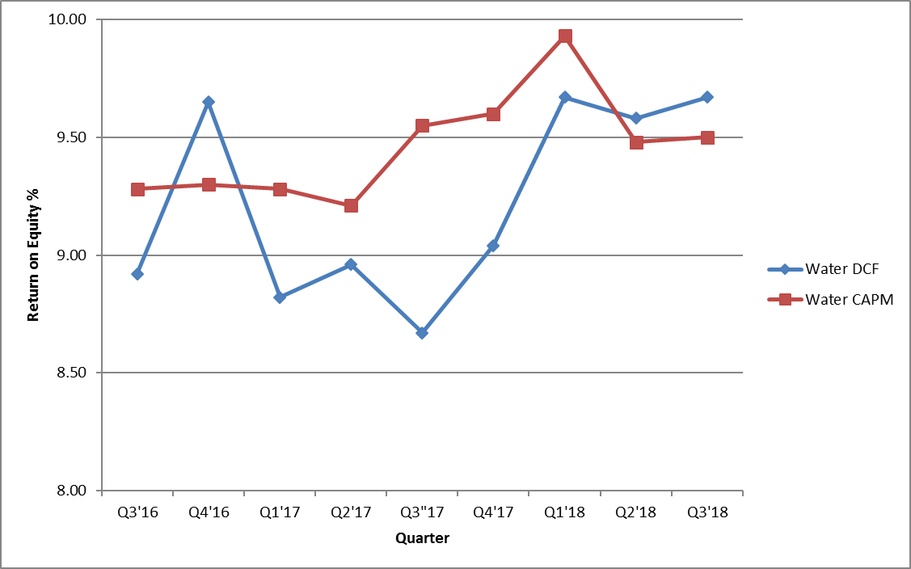

Barometer water companies are used to calculate a current DCF in the first chart. The second chart demonstrates the companies 52 week average DCF. A final average of the two calculations is also shown at the bottom.

Multiple sources of the Barometer companies projected 5 year Earnings Per Share are used to calculate the Group Average Dividend Growth Estimate.

UGI Utilities, Inc. – Electric Division, Duquesne Light Company, PECO Energy - Electric, Columbia Gas, York Water, SUEZ water, and Aqua Pennsylvania have pending rate filings at Docket Nos. R-2017-2640058, R-2018-3000124, R-2018-3000164, R-2018-2647577, R-2018-3000019, R-2018-3000834, and R-2018-3003068 respectively, and filed a letter with the Secretary in place of a report in accordance with 52 Pa. Code § 71.4.
Each utility lists adjustments on Schedule B of their quarterly financial report.
The ROE is approved in a utility's most recent fully litigated base rate proceeding for which a final order was entered not more than two years prior to the effective date of the DSIC. If more than two years have elapsed between the entry of a final order and the DSIC effective date, the ROE is from this report. If the base rate proceeding is settled, without a stipulated ROE, the ROE is from this report.

