PENNSYLVANIA PUBLIC UTILITY COMMISSION

Public Meeting held July 30, 2015
Docket Number: M-2015-2493294

BUREAU OF TECHNICAL UTILITY SERVICES

REPORT ON THE QUARTERLY EARNINGS

OF JURISDICTIONAL UTILITIES

FOR THE YEAR ENDED

March 31, 2015

Gladys M. Brown, Chairman
John F. Coleman, Jr., Vice Chairman
James H. Cawley
Pamela A. Witmer
Robert F. Powelson

TABLE OF CONTENTS
Page No.

Introduction ..................................................................................................... 5
West Penn Power Company, Pennsylvania Power Company, Pennsylvania Electric Company, Metropolitan Edison Company, PPL Electric Utilities Corporation, PECO Energy-Electric, and Columbia Gas had a pending rate filing at Docket Nos. R-2014-2428742, R-2014-2428744, R-2014-2428743, R-2014-2428745, R-2015-2469275, R-2015-2468981, and R-2015-2468056, respectively, and filed a letter with the Secretary in place of a report in accordance with 52 Pa. Code § 71.4.

Attachment A – Summary of Equity Returns……………………………… 6

Attachment B – Summary of Returns 10
This chart depicts the overall and equity returns (actual and adjusted) for the filing utilities for the current quarter. The last authorized equity return and the year authorized is also shown.

Attachment C – Allowed Rates of Return on Common Equity 13
This is a historical chart that shows the most recent fully litigated rate cases for select companies in electric, gas, and water. A docket number followed by their final return on equity and year is also given.

Attachment D – Market Based Returns on Equity – Electric 14
The market indicated common equity cost rate range consists of data used from the electric barometer groups and is based on a series of calculations to average the DCF methods. Also indicates Distribution System Improvement Charge Return.

Attachment D – Electric Barometer Group Calculation of a Current and 52 Week Average Dividend Yield 15
Electric barometer companies are used to calculate a current DCF in the first chart. The second chart demonstrates the companies 52 week average DCF. A final average of the two calculations is also shown at the bottom.

Attachment D – Development of a Representative Dividend Growth Rate…………………………………………………... 16
Multiple sources of the gas barometer companies projected 5 year Earnings Per Share are used to calculate the Group Average Dividend Growth Estimate.

Attachment D – Common Equity Ratios of Electric Barometer Companies 17
The Common Equity Ratios of Electric Utility Barometer Companies table depicts each company’s common equity ratio. The range of reasonable equity ratios consists of the lowest and highest common equity ratio in the quarter for the barometer group companies.

Attachment D – Capital Structure and Cost of Debt and Preferred Stock 18
The Capital Structure and Cost of Debt and Preferred Stock table is taken from the Schedule E and Schedule F of each Pennsylvania electric company’s quarterly earnings report.

Attachment E – Market Based Returns on Equity – Gas 19
The market indicated common equity cost rate range consists of data used from the gas barometer groups and is based on a series of calculations to average the DCF methods. Also indicates Distribution System Improvement Charge Return.

Attachment E – Gas Barometer Group Calculation of a Current and 52 Week Average Dividend Yield 20
Gas barometer companies are used to calculate a current DCF in the first chart. The second chart demonstrates the companies 52 week average DCF. A final average of the two calculations is also shown at the bottom.

Attachment E – Development of a Representative Dividend Growth Rate…………………………………………………... 21
Multiple sources of the gas barometer companies projected 5 year Earnings Per Share are used to calculate the Group Average Dividend Growth Estimate.

Attachment F – Market Based Returns on Equity – Water 22
The market indicated common equity cost rate range consists of data used from the water barometer groups and is based on a series of calculations to average the DCF methods. Also indicates Distribution System Improvement Charge Return.

Attachment F – Water Barometer Group Calculation of a Current and 52 Week Average Dividend Yield 23
Water barometer companies are used to calculate a current DCF in the first chart. The second chart demonstrates the companies 52 week average DCF. A final average of the two calculations is also shown at the bottom.

Attachment F – Development of a Representative Dividend Growth Rate…………………………………………………... 24
Multiple sources of the water barometer companies projected 5 year Earnings Per Share are used to calculate the Group Average Dividend Growth Estimate.

Introduction:

On September 20, 1991, the Commission initiated a rulemaking at L-00910061 pertaining to earnings disclosures by the public utilities subject to its jurisdiction. At that docket, the Commission stated that the submission of accurate, reliable and complete earnings disclosure reports, at regular intervals, is essential to the fulfillment of the broad regulatory oversight responsibilities entrusted to the Commission by the Legislature in the Public Utility Code. The earnings disclosure regulations promulgated by the Commission were adopted October 1, 1992, and published January 23, 1993, at 23 Pa.B. 463. Based upon those regulations, codified at 52 Pa. Code, Chapter 71, a reporting format was developed and distributed to the jurisdictional fixed utilities of Pennsylvania.

All fixed utilities having jurisdictional revenues of $1,000,000 or more, for a calendar year, are required to file the report by March 31 of each year. Such reports are to be based upon the results of operations for the 12-month period ending December 31 of the prior year. Utilities having more than $10,000,000 in jurisdictional revenues are also required to file reports for the 12 months ending on March 31, June 30, and September 30 of each year. On November 30, 2004, however, the Pennsylvania General Assembly signed into law Act 183 concerning alternative telecommunications regulation and broadband deployment. As a result of Act 183, the reporting requirements for the PUC jurisdictional telecommunications companies of Pennsylvania have been streamlined at section 3015(e) of the Public Utility Code. A quarterly earnings report is not listed among those reports now required of PUC jurisdictional telecommunications utilities in Pennsylvania and, therefore, this report does not address telephone company earnings.

The reports have been filed for the period ended March 31, 2015. The Finance Staff of the Bureau of Technical Utility Services has reviewed the reports and has prepared this summary report for public release. This report sets forth the achieved return on equity for each company, the last allowed return for that utility, a market return as determined through the analysis of the barometer group data and the most recent returns allowed, per industry, by the Pennsylvania Public Utility Commission and by other regulatory bodies. Where a utility has not filed a report, the reasons for not filing are indicated.

Questions pertaining to the preparation and contents of this Report should be directed to Ms. Erin Laudenslager, Manager - Finance, Bureau of Technical Utility Services, at (717) 705-4364.

The equity return summaries that follow in Attachment A are, for each quarter;

ACTUAL
- Based on actual results of operations

and

ADJUSTED
2. Based on company proposed pro forma and ratemaking adjustments

ELECTRIC UTILITIES
EQUITY RETURNS BY QUARTER
QTR  END |  | PECO |  | PPL |  | Duq |  | W Penn |  | PaPwr |  |  |  | UGI |  | Penelec |  | MetEd
 |  | ACT | ADJ | ACT | ADJ | ACT | ADJ | ACT | ADJ |  | ACT | ADJ |  | ACT | ADJ | ACT | ADJ | ACT | ADJ
2009 | 4 | 11.58 | 7.70 |  |  | 9.20 | 9.20 | 8.58 | 8.40 |  | 10.24 | 8.93 |  | 8.03 | 11.15 | 9.71 | 9.21 | 4.23 | 3.36
2010 | 1 |  |  |  |  | 7.48 | 7.48 | 6.69 | 6.69 |  | 12.66 | 11.19 |  | 10.17 | 11.70 | 10.43 | 9.96 | 4.71 | 3.77
 | 2 |  |  |  |  |  |  | 6.41 | 6.41 |  | 12.28 | 10.19 |  | 13.41 | 11.89 | 8.04 | 6.97 | 5.89 | 4.47
 | 3 |  |  |  |  |  |  | 6.63 | 6.63 |  | 12.19 | 10.23 |  | 12.46 | 11.97 | 8.37 | 7.32 | 8.24 | 6.83
 | 4 | 14.35 | 9.61 | 7.91 | 6.98 |  |  | 4.78 | 4.80 |  | 6.88 | 4.69 |  | 12.95 | 11.55 | 9.11 | 8.10 | 6.12 | 4.86
2011 | 1 | 11.74 | 11.34 | 8.31 | 8.31 |  |  | 8.43 | 6.80 |  | 10.90 | 8.55 |  | 13.46 | 13.47 | 9.57 | 8.62 | 10.56 | 9.21
 | 2 | 12.25 | 11.03 | 9.41 | 9.41 | 10.86 | 10.39 | 10.05 | 8.40 |  | 7.41 | 5.81 |  | 14.11 | 12.94 | 6.51 | 6.38 | 7.68 | 6.43
 | 3 | 10.35 | 11.07 | 8.89 | 8.89 | 10.05 | 9.58 | 12.95 | 11.21 |  | 11.67 | 10.05 |  | 14.84 | 12.93 | 8.73 | 8.18 | 9.90 | 7.50
 | 4 | 13.41 | 11.38 |  |  | 10.21 | 9.97 | 13.33 | 11.58 |  | 5.91 | 7.60 |  | 14.60 | 9.79 | 6.45 | 8.43 | 4.24 | 5.23
2012 | 1 | 12.89 | 11.26 |  |  | 10.95 | 10.71 | 11.66 | 13.16 |  | 5.78 | 7.02 |  | 15.04 | 8.42 | 5.76 | 7.54 | 3.90 | 4.64
 | 2 | 12.63 | 12.01 |  |  | 10.81 | 10.42 | 10.61 | 9.15 |  | 8.95 | 8.95 |  | 14.61 | 8.53 | 6.48 | 8.08 | 3.44 | 4.01
 | 3 | 13.14 | 12.66 |  |  | 10.33 | 9.92 | 10.63 | 10.45 |  | 9.69 | 9.54 |  | 15.85 | 9.48 | 7.34 | 8.58 | 5.72 | 6.28
 | 4 | 11.55 | 11.56 | 6.02 | 4.88 | 10.27 | 9.24 | 9.54 | 9.54 |  | 8.41 | 8.27 |  | 14.60 | 8.98 | 5.41 | 7.74 | 5.39 | 6.81
2013 | 1 | 11.92 | 11.27 | 7.56 | 6.24 | 10.12 | 9.74 | 9.23 | 9.23 |  | 8.89 | 8.74 |  | 12.77 | 9.84 | 5.30 | 7.67 | 5.01 | 6.47
 | 2 | 11.40 | 10.74 | 7.80 | 7.37 |  |  | 12.34 | 12.34 |  | 8.85 | 8.70 |  | 11.53 | 10.49 | 5.86 | 8.21 | 5.36 | 6.79
 | 3 | 11.09 | 10.96 | 8.67 | 8.38 |  |  | 9.13 | 9.13 |  | 8.49 | 8.34 |  | 10.74 | 10.65 | -0.77 | 2.07 | -12.43 | -10.43
 | 4 | 11.97 | 10.52 | 10.01 | 9.79 |  |  | 13.73 | 13.73 |  | 14.49 | 14.30 |  | 14.25 | 11.99 | 4.85 | 2.99 | -6.06 | -7.87
2014 | 1 | 9.97 | 10.34 | 10.02 | 10.04 |  |  | 11.58 | 9.45 |  | 15.28 | 15.04 |  | 13.36 | 10.25 | 5.17 | 3.34 | -6.40 | -8.13
 | 2 | 10.05 | 10.08 | 9.50 | 10.09 | 9.77 | 9.29 |  |  |  |  |  |  | 12.64 | 9.21
 | 3 | 8.93 | 9.25 | 10.07 | 9.99 | 9.97 | 9.48 |  |  |  |  |  |  | 8.76 | 9.22
 | 4 | 8.23 | 9.58 |  |  | 9.77 | 9.40 |  |  |  |  |  |  | 9.01 | 10.00
2015 | 1 |  |  |  |  | 10.08 | 9.65 |  |  |  |  |  |  | 10.88 | 10.39
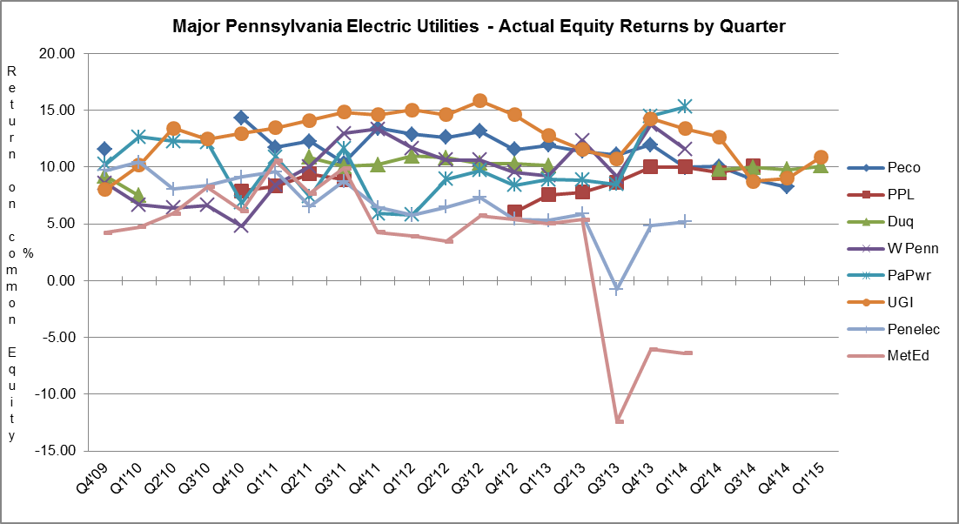

GAS UTILITIES
EQUITY RETURNS BY QUARTER

QTR |  |  | Columbia |  | Peoples |  | PECO |  | UGI |  | Peoples-Eqt |  | NFG |  | UGI Penn |  | Peoples TWP
END |  |  | ACT | ADJ | ACT | ADJ | ACT | ADJ | ACT | ADJ | ACT | ADJ | ACT | ADJ | ACT | ADJ | ACT | ADJ
2009 | 4 |  |  |  | 14.80 | 6.47 | 10.66 | 9.28 | 14.58 | 11.41 | 9.84 | 9.86 | 14.74 | 12.48 | 4.11 | 8.58 | 3.75 | 3.65
2010 | 1 |  |  |  |  |  |  |  | 15.91 | 11.69 | 10.31 | 9.18 | 18.80 | 10.46 | 7.84 | 8.77
 | 2 |  |  |  | 9.65 | 5.25 |  |  | 15.97 | 11.48 | 9.47 | 8.99 | 19.13 | 10.33 | 8.86 | 7.95
 | 3 |  |  |  |  |  |  |  | 14.84 | 11.79 | 8.87 | 8.56 | 18.19 | 10.99 | 8.62 | 9.03
 | 4 |  | 12.50 | 7.67 |  |  | 10.21 | 9.94 | 16.52 | 11.88 | 8.78 | 8.67 | 18.97 | 11.29 | 9.57 | 10.12 | 3.27 | 9.57
2011 | 1 |  |  |  |  |  | 11.74 | 11.34 | 19.61 | 13.11 | 9.48 | 9.78 | 19.87 | 12.11 | 13.08 | 12.17 | 6.52 | 9.06
 | 2 |  |  |  |  |  | 11.97 | 10.79 | 19.67 | 13.92 | 10.81 | 10.71 | 20.83 | 12.97 | 14.08 | 12.65 | 6.10 | 6.94
 | 3 |  |  |  | 5.67 | 8.47 | 12.56 | 11.15 | 18.24 | 11.98 | 10.40 | 9.93 | 21.16 | 13.05 | 14.32 | 11.48 | 5.78 | 6.67
 | 4 |  |  |  |  |  | 11.69 | 12.06 | 16.55 | 9.18 | 7.99 | 8.89 | 19.62 | 12.34 | 14.01 | 9.35 | 6.75 | 5.56
2012 | 1 |  | 8.65 | 11.24 |  |  | 8.98 | 12.09 | 15.71 | 8.95 | 2.29 | 8.05 | 15.76 | 10.51 | 13.22 | 9.63 | 5.24 | 3.39
 | 2 |  | 9.00 | 10.17 |  |  | 8.72 | 12.03 | 13.60 | 9.90 | 5.51 | 7.51 | 14.10 | 10.06 | 13.63 | 10.40 | 4.57 | 6.43
 | 3 |  | 9.27 | 8.88 | 6.21 | 9.35 | 9.98 | 13.48 | 13.79 | 10.05 | 5.84 | 7.79 | 13.88 | 10.39 | 13.16 | 10.66 | 7.02 | 7.41
 | 4 |  |  |  | 11.24 | 9.57 | 12.42 | 15.10 | 13.68 | 9.44 | 7.27 | 8.05 | 15.11 | 10.17 | 13.31 | 10.63 | 5.05 | 6.94
2013 | 1 |  |  |  | 12.49 | 9.89 | 14.63 | 15.13 | 14.65 | 10.27 | 12.42 | 8.40 | 19.33 | 10.25 | 13.28 | 10.58
 | 2 |  | 10.85 | 7.15 | 16.59 | 8.35 | 14.43 | 14.40 | 13.02 | 10.21 | 10.40 | 8.92 | 20.18 | 10.25 | 10.98 | 10.27
 | 3 |  | 9.36 | 9.86 | 17.39 | 8.72 | 14.14 | 14.01 | 12.60 | 9.38 | 9.84 | 9.48 | 19.61 | 10.72 | 10.59 | 10.76
 | 4 |  | 10.60 | 10.78 | 16.33 | 10.02 | 14.35 | 13.97 | 16.08 | 9.20 | 10.52 | 9.76 | 20.51 | 10.07 | 13.41 | 10.49 | 7.21 | 12.23
2014 | 1 |  |  |  | 14.68 | 9.94 | 15.23 | 13.52 | 16.81 | 8.35 | 12.00 | 8.73 | 23.11 | 9.78 | 16.67 | 10.06 | 12.19 | 11.87
 | 2 |  |  |  | 13.05 | 9.78 | 15.32 | 13.24 | 16.71 | 8.39 | 13.54 | 8.49 | 22.97 | 12.00 | 15.30 | 10.90 | 14.06 | 12.32
 | 3 |  |  |  | 13.43 | 9.16 | 15.45 | 13.21 | 16.63 | 8.64 | 14.41 | 9.15 | 21.36 | 11.03 | 13.77 | 10.15 | 15.07 | 12.62
 | 4 |  | 9.71 | 9.97 | 11.85 | 7.89 | 13.86 | 12.59 | 15.00 | 7.93 | 14.52 | 12.46 | 20.40 | 10.79 | 15.64 | 9.82 | 16.91 | 11.83
2015 | 1 |  |  |  | 14.22 | 7.90 | 14.60 | 13.01 | 15.76 | 7.87 | 15.36 | 12.14 | 20.17 | 10.31 | 15.57 | 9.52 | 16.36 | 11.23
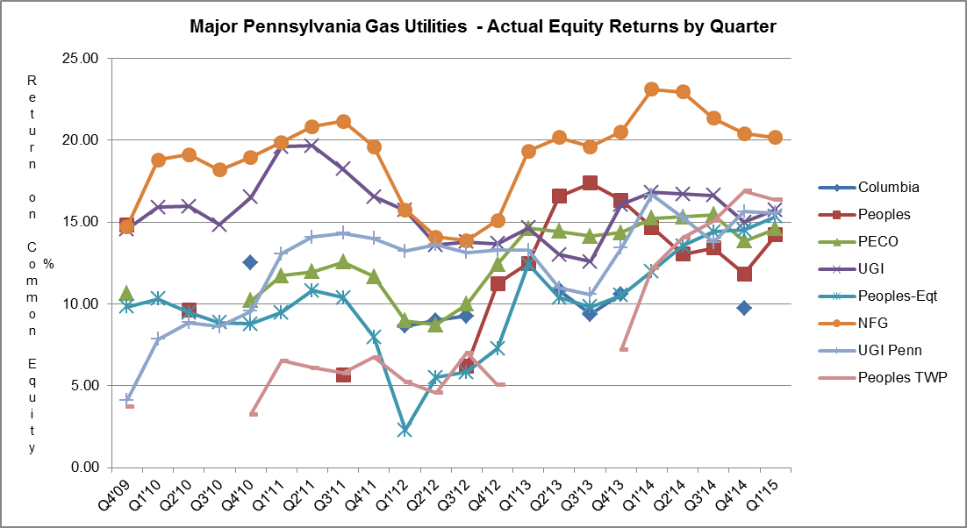

WATER UTILITIES
EQUITY RETURNS BY QUARTER
QTR |  | PAWC |  | AQUA |  | United |  | York |  | Superior
END |  | ACT | ADJ | ACT | ADJ | ACT | ADJ | ACT | ADJ | ACT | ADJ
2009 | 4 |  |  |  |  | 5.66 | 5.84 | 8.80 | 9.00
2010 | 1 | 8.72 | 8.10 |  |  | 5.74 | 6.57 | 8.90 | 8.70
 | 2 | 9.30 | 9.30 |  |  | 6.59 | 7.54
 | 3 | 9.58 | 9.58 | 10.19 | 10.35 | 7.15 | 8.34
 | 4 | 9.18 | 8.52 | 10.10 | 8.94 | 4.66 | 8.69 | 10.4 | 11.2
2011 | 1 |  |  | 10.68 | 8.32 | 5.02 | 8.81 | 10.8 | 11.1
 | 2 |  |  | 10.92 | 7.93 | 4.72 | 8.61 | 11.1 | 10.2
 | 3 |  |  |  |  | 3.92 | 7.69 | 10.9 | 10.2
 | 4 |  |  |  |  | 7.69 | 8.00 | 10.8 | 10.0
2012 | 1 | 8.98 | 8.98 |  |  | 7.38 | 7.84 | 10.7 | 9.5
 | 2 | 9.06 | 9.06 |  |  | 7.30 | 7.65 | 10.4 | 9.4
 | 3 | 9.17 | 9.17 | 9.50 | 7.77 | 7.96 | 8.38 | 10.5 | 9.1
 | 4 | 9.54 | 9.04 | 12.41 | 12.56 | 8.33 | 8.49 | 10.4 | 9.1
2013 | 1 |  |  | 13.24 | 11.96 | 8.53 | 8.71
 | 2 |  |  | 14.26 | 12.52 | 8.99 | 9.15 |  |  | 8.57 | 7.85
 | 3 |  |  | 15.49 | 12.21 | 8.83 | 9.01 |  |  | 7.46 | 6.85
 | 4 |  |  | 13.77 | 11.97 | 8.43 | 9.05 | 10.2 | 10.8 | 10.71 | 10.01
2014 | 1 | 10.52 | 9.98 | 13.29 | 11.56 | 8.45 | 9.02 | 10.2 | 10.2 | 13.12 | 9.97
 | 2 | 10.51 | 10.02 | 13.01 | 11.42 | 8.81 | 9.32 | 10.7 | 10.7 | 17.09 | 9.61
 | 3 | 11.11 | 10.57 | 12.82 | 11.29 | 8.57 | 9.06 | 10.9 | 10.9 | 34.68 | 9.88
 | 4 | 10.49 | 9.38 | 12.62 | 11.49 | 8.90 | 9.44 | 12.3 | 11.6 | 16.74 | 7.96
2015 | 1 | 10.33 | 9.14 | 12.46 | 11.11 | 9.11 | 9.83 | 12.7 | 12.7

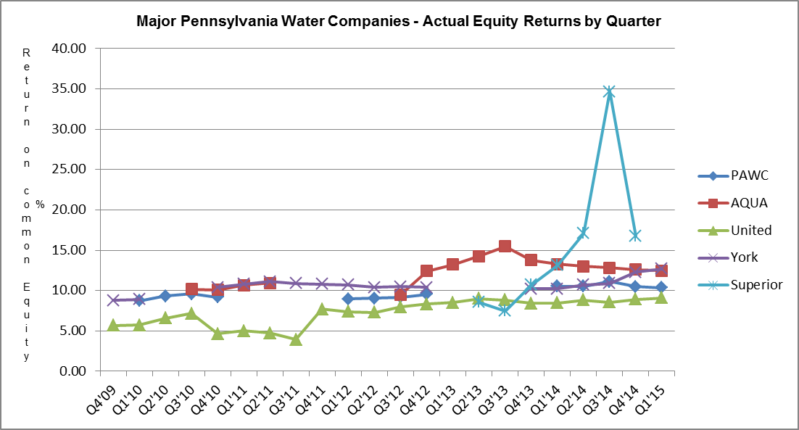

Attachment B includes:

A. Overall Returns on rate base
1. Actual
2. Company proposed pro forma and ratemaking adjustments

and

B. Equity Returns
1. Actual
2. Company proposed pro forma and ratemaking adjustments

Attachment B
1 of 2
Summary of Returns
for the Year Ended March 31, 2015
 | OVERALL | RETURN |  | EQUITY | RETURN | ROE | YEAR
COMPANY NAME | ACTUAL | ADJ |  | ACTUAL | ADJ | AUTH | AUTH
ELECTRIC
$10,000,000 Revenues
PECO Energy* |  |  |  |  |  | Settled | 2010
PPL Electric Utilities Corp.* |  |  |  |  |  | 10.40 | 2012
Duquesne Light Company | 7.76 | 7.51 |  | 10.08 | 9.65 | Settled | 2014
West Penn Power Company* |  |  |  |  |  | 11.50 | 1995
Pennsylvania Power Company* |  |  |  |  |  | 12.91 | 1988
UGI Utilities, Inc. | 8.58 | 8.03 |  | 10.88 | 10.39 | Settled | 1996
Pennsylvania Electric Company* |  |  |  |  |  | 10.10 | 2007
Metropolitan Edison Company* |  |  |  |  |  | 10.10 | 2007
GAS
$10,000,000 Revenues
Columbia Gas of PA, Inc.* |  |  |  |  |  | Settled | 2013
Peoples Natl Gas LLC | 10.12 | 6.09 |  | 14.22 | 7.90 | Settled | 2012
PECO Energy | 10.33 | 9.42 |  | 14.60 | 13.01 | Settled | 2010
UGI Utilities, Inc. | 11.36 | 6.64 |  | 15.76 | 7.87 | Settled | 1995
Peoples-Equitable Division | 10.10 | 8.22 |  | 15.36 | 12.14 | Settled | 2008
National Fuel Gas Distribution Co. | 12.84 | 7.69 |  | 20.17 | 10.31 | Settled | 2006
UGI Penn Natural Gas, Inc. | 10.70 | 7.55 |  | 15.57 | 9.52 | Settled | 2009
Peoples TWP, LLC | 10.78 | 7.97 |  | 16.36 | 11.23 | Settled | 2013
UGI Central Penn Gas, Inc. | 13.23 | 8.50 |  | 18.33 | 11.25 | Settled | 2009
WATER
$10,000,000 Revenues
PA American Water Company | 8.14 | 7.54 |  | 10.33 | 9.14 | Settled | 2013
AQUA Pennsylvania | 9.11 | 8.37 |  | 12.46 | 11.11 | Settled | 2012
York Water Company | 9.8 | 9.8 |  | 12.7 | 12.7 | Settled | 2014
United Water Penna. Inc. | 7.74 | 8.14 |  | 9.11 | 9.83 | Settled | 2009
* West Penn Power Company, Pennsylvania Power Company, Pennsylvania Electric Company, Metropolitan Edison Company, PPL Electric Utilities Corporation, PECO Energy-Electric, and Columbia Gas had a pending rate filing at Docket Nos. R-2014-2428742, R-2014-2428744, R-2014-2428743, R-2014-2428745, R-2015-2469275, R-2015-2468981, and R-2015-2468056, respectively, and filed a letter with the Secretary in place of a report in accordance with 52 Pa. Code § 71.4.
Attachment B
2 of 2

Peoples Natural Gas Company

Return on equity adjusted from 14.22% to 7.90% based on the following company adjustments to actual results of operations.

- $ 72,366,000 Rate Base Plant Normalization Increase
- $ (38,119,000) Rate Base Depreciation Normalization Decrease
- $ (14,894,000) Rate Base Deferred Taxes Decrease
- $ (114,899,000) Revenue Annualization/Normalization Decrease
- $ (93,010,000) Expense Annualization/Normalization Decrease
- $ (9,083,000) Tax Annualization/Normalization Decrease

UGI Utilities, Inc.-Gas

Return on equity adjusted from 15.76% to 7.87% based on the following company adjustments to actual results of operations.

- $ 165,497,000 Rate Base Plant in Service Increase
- $ 12,467,000 Rate Base Inventory Increase
- $ (26,762,000) Rate Base Liberalized Depreciation Decrease
- $ (25,771,000) Normalization of Operating Revenue Decrease
- $ 5,469,000 Depreciation Expense Increase
- $ 5,482,000 Payroll Expense Increase
- $ (15,407,000) Tax Expense Decrease

National Fuel Gas Distribution Corporation

Return on equity adjusted from 20.17% to 10.31% based on the following company adjustments to actual results of operations.

- $ 27,519,000 Rate Base Plant Increase
- $ 37,739,000 Rate Base Cash Working Capital Increase
- $ (19,834,000) Operating Revenue Decrease
- $ (9,359,000) Operating and Maintenance Decrease
- $ (9,731,000) Federal Income Tax Decrease

UGI Central Penn Gas, Inc.

Return on equity adjusted from 18.33% to 11.25% based on the following company adjustments to actual results of operations.

- $ 78,177,000 Rate Base Plant Increase
- $ (8,688,000) Rate Base Depreciation Decrease
- $ (5,396,000) Normalization of Operating Revenue Decrease
- $ (3,896,000) Tax Expense Decrease

Attachment C

ALLOWED RATES OF RETURN ON COMMON EQUITY
This is a historical chart that shows the most recent fully litigated rate cases for select companies in electric, gas, and water. A docket number followed by their final return on equity and year is also given.

ELECTRIC Docket Number ROE (%) Year

Recent PA PUC Allowed
PPL Electric Utilities Corp. R-2012-2290597 10.40 2012
PECO Energy Company R-2010-2161575 Settled 2010
UGI - Electric R-00953524 Settled 1996
Pennsylvania Electric Company R-2014-2428743 Settled 2015
Metropolitan Edison Company R-2014-2428745 Settled 2015
Pennsylvania Power Company R-2014-2428744 Settled 2015
West Penn Power Company R-2014-2428742 Settled 2015

Current Market Indicated ROE as calculated by the 6.84-10.71
Bureau of Technical Utility Services.

GAS

Recent PA PUC Allowed
Columbia Gas of Pa. R-2014-2406274 Settled 2014
UGI Utilities, Inc. – Gas R-00953297 Settled 1995
Peoples Natural Gas R-2012-2285985 Settled 2012
UGI Penn Natural Gas R-2008-2079660 Settled 2009
UGI Central Penn Gas R-2008-2079675 Settled 2009
PECO Energy R-2010-2161592 Settled 2010
Peoples TWP R-2013-2355886 Settled 2013

Current Market Indicated ROE as calculated by the 7.17-12.08
Bureau of Technical Utility Services.

WATER

Recent PA PUC Allowed
Aqua Pennsylvania R-2011-2267958 Settled 2012
PA American Water R-2013-2355276 Settled 2013
Columbia Water R-2013-2360798 9.75 2014
York Water R-2012-2336379 Settled 2014

Current Market Indicated ROE as calculated by the 8.17-9.44
Bureau of Technical Utility Services.

The market indicated common equity cost rate range consists of data used from the barometer groups and is based on a series of calculations to average the DCF methods.

Barometer electric companies are used to calculate a current DCF in the first chart. The second chart demonstrates the companies 52 week average DCF. A final average of the two calculations is also shown at the bottom.

Multiple sources of the Barometer companies projected 5 year Earnings Per Share are used to calculate the Group Average Dividend Growth Estimate.

The Common Equity Ratios of Electric Utility Barometer Companies table depicts each company’s quarterly common equity ratio. The range of Reasonable Equity Ratios consists of the lowest and highest common equity ratio for the barometer group companies.

Company
Consolidated Edison

Dominion Resources
PPL Corporation
Public Service Enterprise Group
Duke Energy Corporation
Eversource Energy
Average
Range of Reasonable Equity Ratios
48.50%

43.50%

55.50%

Common Equity Ratios of Electric Utility Barometer Groups (2)
2015 Common Equity Ratio (1)
51.50%

41.50%

(1) Source: Value Line Investment Survey July 7, 2015
(2) The common equity ratios reported by Value Line exclude short-term
debt and current maturities of long-term debt.

53.00%

48.92%

41.50-55.50%

The Capital Structure and Cost of Debt and Preferred Stock table shows the Schedule E and Schedule F of each company’s quarterly earnings report.

The market indicated common equity cost rate range consists of data used from the barometer groups and is based on a series of calculations to average the DCF methods.

Barometer gas companies are used to calculate a current DCF in the first chart. The second chart demonstrates the companies 52 week average DCF. A final average of the two calculations is also shown at the bottom.

Multiple sources of the Barometer companies projected 5 year Earnings Per Share are used to calculate the Group Average Dividend Growth Estimate.

The market indicated common equity cost rate range consists of data used from the barometer groups and is based on a series of calculations to average the DCF methods.
Barometer water companies are used to calculate a current DCF in the first chart. The second chart demonstrates the companies 52 week average DCF. A final average of the two calculations is also shown at the bottom.

Multiple sources of the Barometer companies projected 5 year Earnings Per Share are used to calculate the Group Average Dividend Growth Estimate.

West Penn Power Company, Pennsylvania Power Company, Pennsylvania Electric Company, Metropolitan Edison Company, PPL Electric Utilities Corporation, PECO Energy-Electric, and Columbia Gas had a pending rate filing at Docket Nos. R-2014-2428742, R-2014-2428744, R-2014-2428743, R-2014-2428745, R-2015-2469275, R-2015-2468981, and R-2015-2468056, respectively, and filed a letter with the Secretary in place of a report in accordance with 52 Pa. Code § 71.4.

